**Data Reporting:**

2. Create a dashboard in tableau by choosing appropriate chart types and metrics useful for the business. The dashboard must entail the following:

a. Pie chart to describe the diabetic or non-diabetic population

b. Scatter charts between relevant variables to analyze the relationships

c. Histogram or frequency charts to analyze the distribution of the data

d. Heatmap of correlation analysis among the relevant variables

e. Create bins of these age values: 20-25, 25-30, 30-35, etc. Analyze different variables for these age brackets using a bubble chart

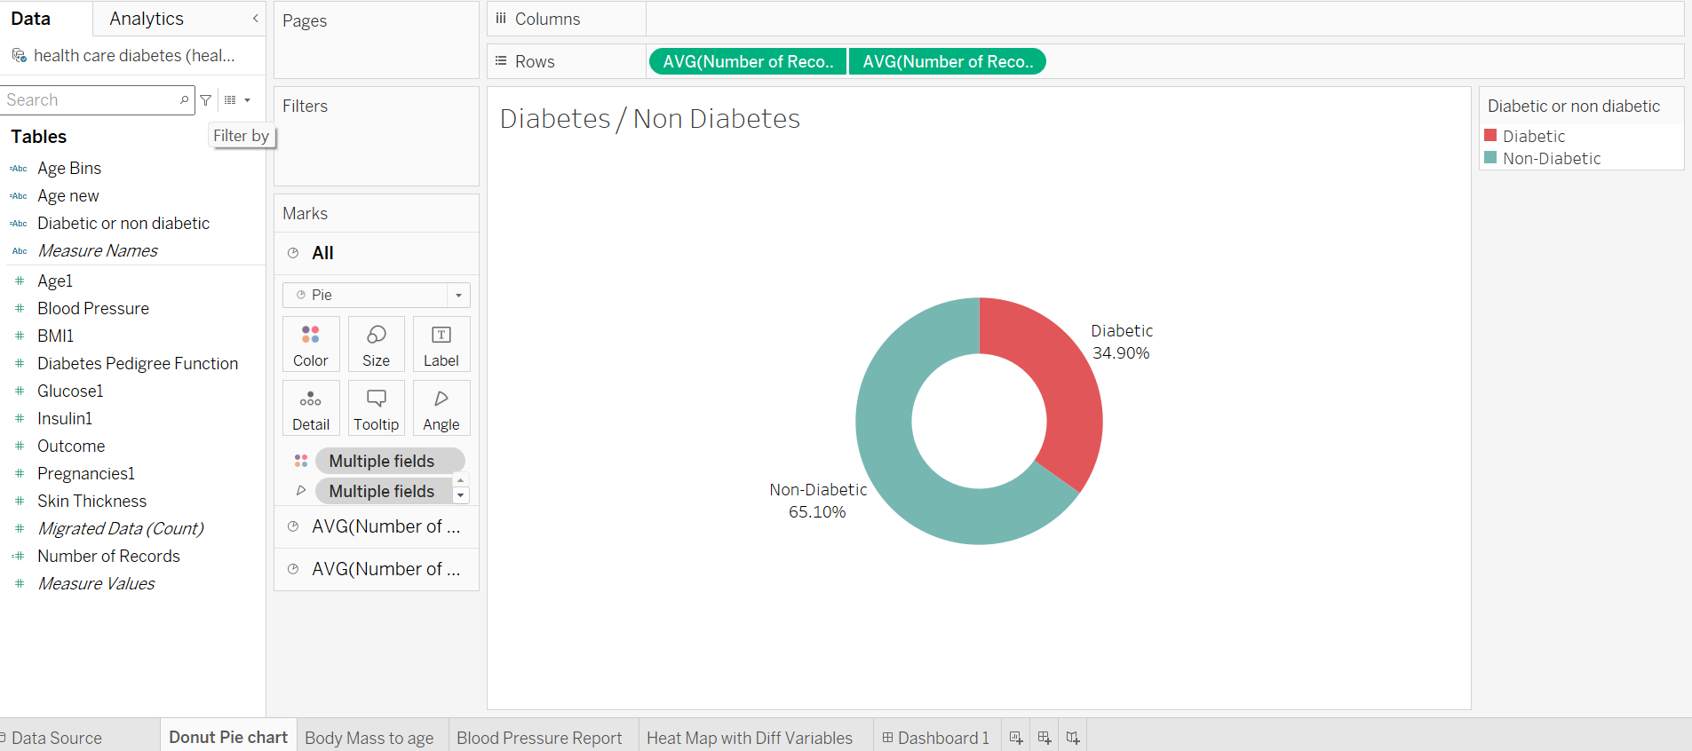

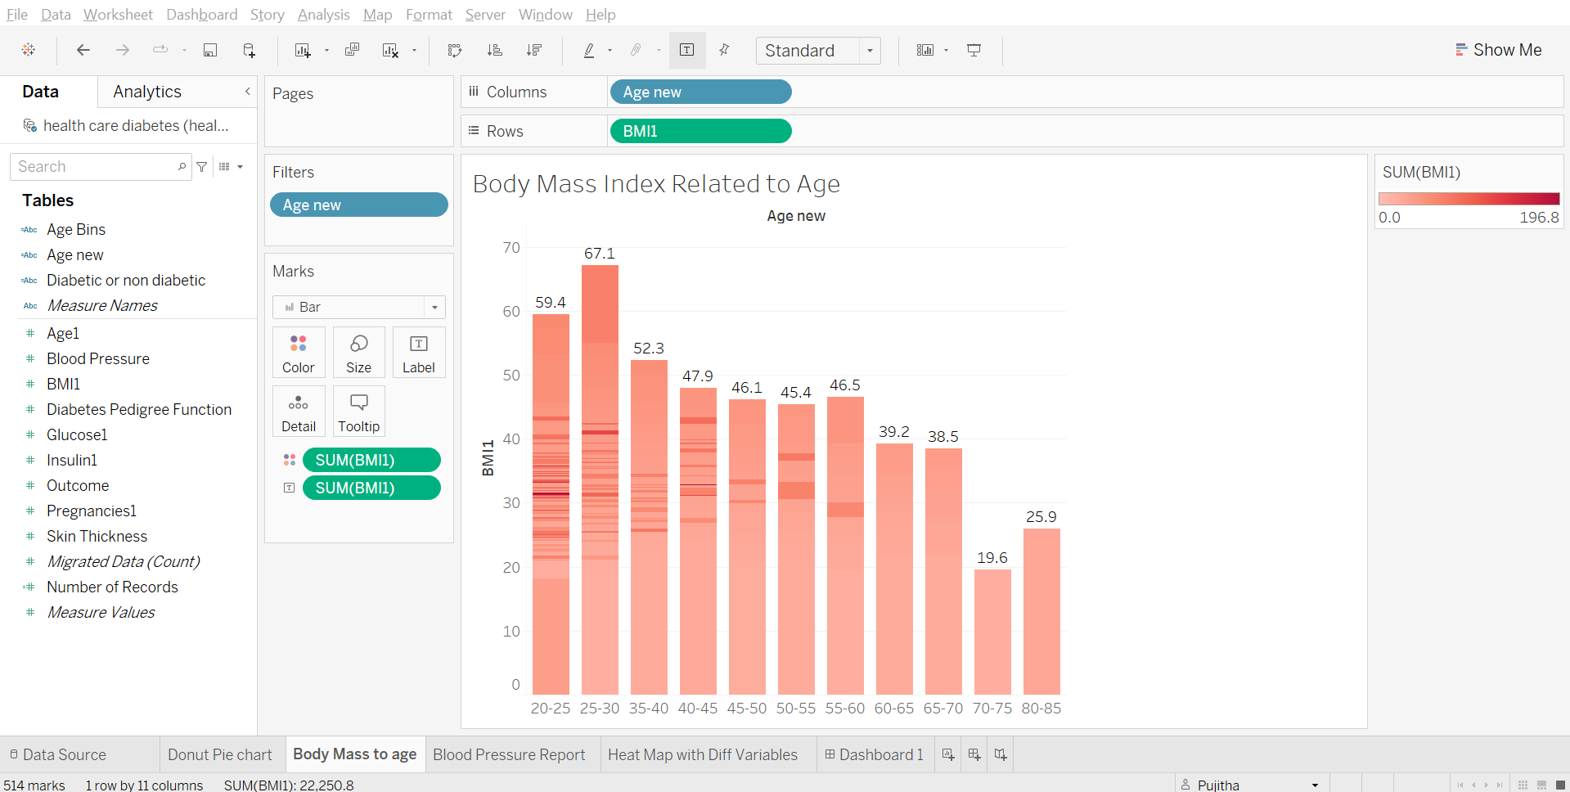

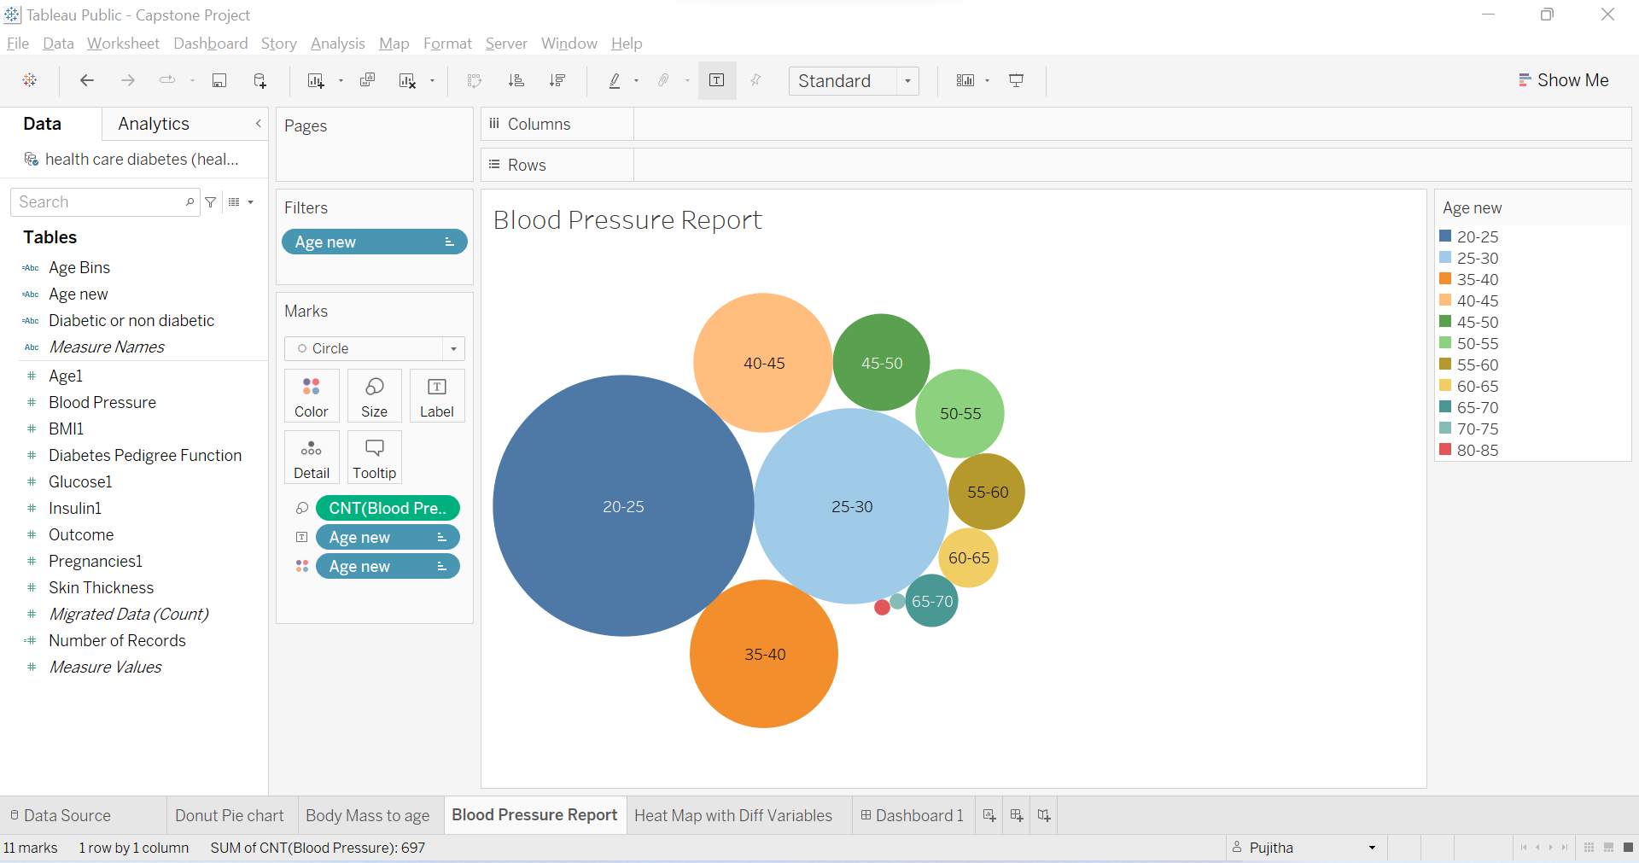

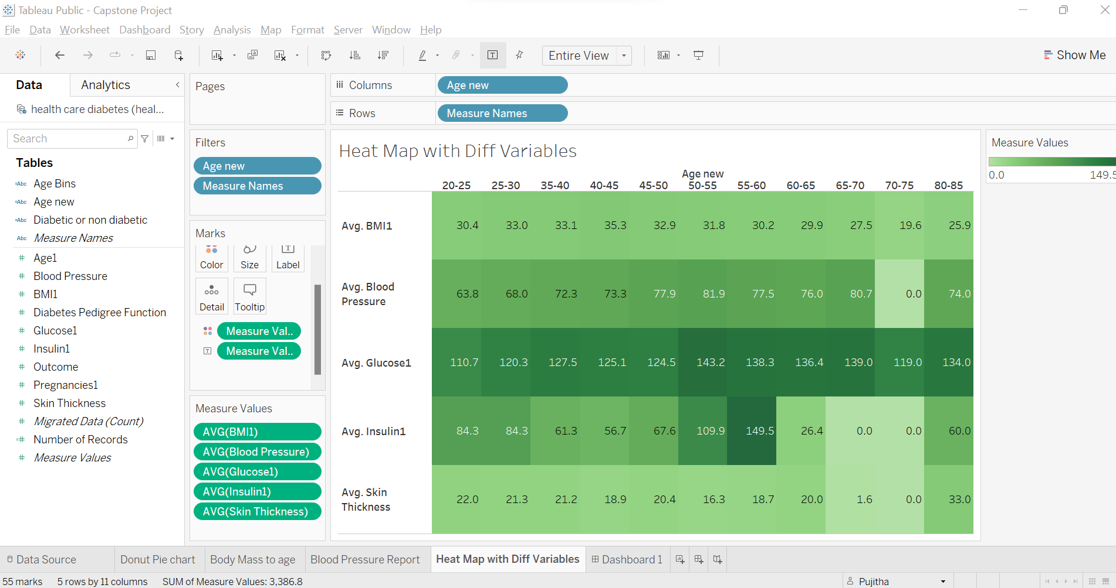

Tableau Dashboard:

